The Title Goes Here with Each Initial Letter Capitalized (Style: Paper Title)
Author’s Name^{1, a)} and Author’s Name^{2, 3, b)} (style: Paper Author)
¹(Use the Microsoft Word template style: Author Affiliation) Replace this text with an author’s affiliation
(use complete addresses). Note the use of superscript “a)” to indicate the author’s e-mail address below.
Use b), c), etc. to indicate e-mail addresses for more than 1 author.
²Additional affiliations should be indicated by superscript numbers 2, 3, etc. as shown above.
³You would list an author’s second affiliation here.
^{a)}Corresponding author: your@emailaddress.xxx (Style: Author Email)
^{b)}anotherauthor@thisaddress.yyy
Abstract. A single paragraph of about 200 words maximum. For research articles, abstracts should give a pertinent overview of the work. We strongly encourage authors to use the following style of structured abstracts, but without headings: (1) Background: Place the question addressed in a broad context and highlight the purpose of the study; (2) Methods: Describe briefly the main methods or treatments applied; (3) Results: Summarize the article's main findings; and (4) Conclusions: Indicate the main conclusions or interpretations. The abstract should be an objective representation of the article, it must not contain results which are not presented and substantiated in the main text and should not exaggerate the main conclusions. To format your abstract, use the Microsoft Word template style: Abstract. Each paper must include an abstract. Begin the abstract with the word “Abstract” followed by a period in bold font, and then continue with a normal 9 point font.

Introduction (First level heading. Style: heading 1)
The introduction should briefly place the study in a broad context and highlight why it is important. It should define the purpose of the work and its significance. The current state of the research field should be reviewed carefully and key publications cited. Please highlight controversial and diverging hypotheses when necessary. Finally, briefly mention the main aim of the work and highlight the principal conclusions. As far as possible, please keep the introduction comprehensible to scientists outside your particular field of research. References should be numbered in order of appearance and indicated by a numeral or numerals in square brackets, e.g., [1] or [2,3], or [4–6]. See the end of the document for further details on references.
To format a paragraph, use the Microsoft Word template style: Paragraph. Do not include any headers, footers, or page numbers in your document. They will be added to your article PDF by AIP Publishing, so please do not amend this template to add them to your paper.

Materials and Methods
Materials and Methods should be described with sufficient details to allow others to replicate and build on published results. Please note that publication of your manuscript implicates that you must make all materials, data, computer code, and protocols associated with the publication available to readers. Please disclose at the submission stage any restrictions on the availability of materials or information. New methods and protocols should be described in detail while well-established methods can be briefly described and appropriately cited.
Research manuscripts reporting large datasets that are deposited in a publicly available database should specify where the data have been deposited and provide the relevant accession numbers. If the accession numbers have not yet been obtained at the time of submission, please state that they will be provided during review. They must be provided prior to publication.
Interventionary studies involving animals or humans, and other studies require ethical approval must list the authority that provided approval and the corresponding ethical approval code.

How to Apply the Template Paragraph Styles (Second Level Heading. Style: Heading 2)
Here is how to display a pop-up window from which to select and apply the template paragraph styles:
  Click here to display the Styles window – making it easy to choose and apply the AIP Proceedings template styles.  To apply a style to a paragraph, click anywhere in the paragraph text then click on the appropriate style listed in the Styles window. | 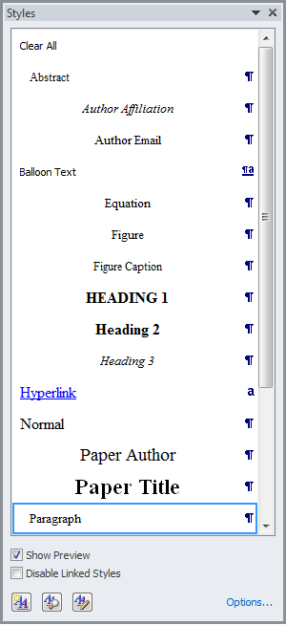

How to Use this Template (Second Level Heading)
You can edit or delete the content provided in this template and replace it with the text and figures of your article. Please be sure you do not accidentally leave any of this text as part of your paper!

Heading with Each Initial Letter Capitalized (Second Level Heading)
You can edit or delete the content provided in this template and replace it with the text and figures of your article. Please be sure you do not accidentally leave any of this text as part of your paper!

Heading with Each Initial Letter Capitalized (Third Level Heading: Heading 3)
As with first and second level headings, all words except prepositions and articles (see above) should appear with initial letters in uppercase.

Results (Results and discussion) (first level heading)
This section may be divided by subheadings. It should provide a concise and precise description of the experimental results, their interpretation as well as the experimental conclusions that can be drawn.
Results and Discussion can be divided, or combined into one section, as Results and Discussion.
Authors should discuss the results and how they can be interpreted in perspective of previous studies and of the working hypotheses. The findings and their implications should be discussed in the broadest context possible. Future research directions may also be highlighted.

Formatting and Inserting Equations (Second Level Heading)
Equations should be centered with equation numbers on the right-hand side (flush right). Achieving a pleasing layout of equations can be tricky in Microsoft Word, so here are some tips. You can either:
- Copy, paste, and edit the sample equation provided (recommended), or
- Manually insert an equation and equation number

Copy, Paste, and Edit a Sample Equation (Third Level Heading)
To use this “Old Style Equation” as a “template,” highlight the entire line, then use cut and paste to the new location. Note that the equation number will automatically update (increment).

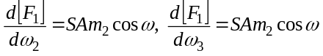

Figures (Second Level Heading)
Figures, tables, and equations must be inserted in the text and may not be grouped at the end of the paper. Important: A miscount of figures, tables, or equations may result from revisions. Please double check the numbering of these elements before you submit your paper to your proceedings editor.
If you need to arrange a number of figures, a good tip is to place them in a table, which gives you additional control of the layout. Leave a line space between your figure and any text above it, like this one:

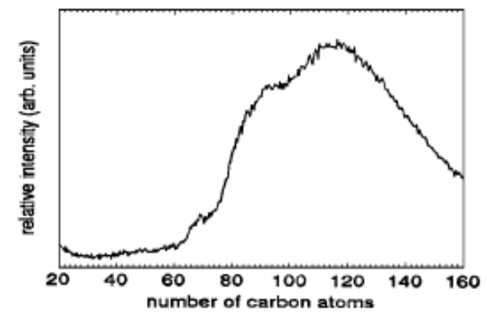 | 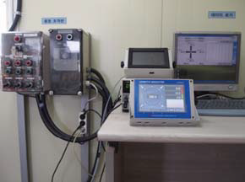
(a) | (b)
Figure 1. To format a figure caption use the Microsoft Word template style: Figure Caption. The text “FIGURE 1,” which
labels the caption, should be bold and in upper case. If figures have more than one part, each part should be labeled (a), (b), etc. Using a table, as in the above example, helps you control the layout

Cite all figures in the text consecutively. The word “Figure” should be spelled out if it is the first word of the sentence and abbreviated as “Fig.” elsewhere in the text. Place the figures as close as possible to their first mention in the text at the top or bottom of the page with the figure caption positioned below, all centered. Figures must be inserted in the text and may not follow the Reference section. Set figure captions in 9 point size, Times Roman font. Type the word “FIGURE 1.” in bold uppercase, followed by a period.

Tables (Second Level Heading)
Due to the wide range and complexity of tables, we simply offer an example for guidance. Please follow the style for table (and figure) captions.
TABLE 1. To format a table caption, use the Microsoft Word template style: Table Caption. The text “TABLE 1,” which labels the caption, should be bold and all letters capitalized. Center this text above the Table. Tables should have top and bottom rules, and a rule separating the column heads from the rest of the table only.
Column Header Goes Here | Column Header Goes Here | Column Header Goes Here
Row Name Here | x | x
Row Name Here | x | x
Row Name Here | x | x

Conclusions
This section is mandatory for research article.

Acknowledgments
This study was supported by xxxx.

References
The reference section will follow the “Acknowledgment” section. References should be numbered using Arabic numerals followed by a period (.) as shown below, and should follow the format in the below examples.

- M. P. Brown and K. Austin, The New Physique (Publisher Name, Publisher City, 2005), pp. 25–30.
- M. P. Brown and K. Austin, Appl. Phys. Letters 85, 2503–2504 (2004).
- R. T. Wang, “Title of Chapter,” in Classic Physiques, edited by R. B. Hamil (Publisher Name, Publisher City, 1999), pp. 212–213.
- C. D. Smith and E. F. Jones, “Load-cycling in cubic press,” in Shock Compression of Condensed Matter-2001, AIP Conference Proceedings 620, edited by M. D. Furnish et al. (American Institute of Physics, Melville, NY, 2002), pp. 651–654.
- B. R. Jackson and T. Pitman, U.S. Patent No. 6,345,224 (8 July 2004)
- D. L. Davids, “Recovery effects in binary aluminum alloys,” Ph.D. thesis, Harvard University, 1998.
- R. C. Mikkelson (private communication).

